**CSF 2113 Lab 07: File Handling**

1. Create a file in home directory and name it myfile.txt.

Write the code segment to read and display the information from the file. Read one line at a time and print each line after stripping the whitespaces.

File name: myfile.txt

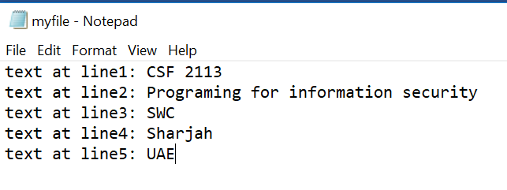

|  |
| --- |
| Code: |
| Output: |

1. Write the code segment to read and display the information from the file. (Same file used in Question a). Read In one go using **readlines()** function.

|  |
| --- |
| Code: |
| Output: |

1. Write the code segment to read and display the information from the file. (Same file used in Question a). Read In one go using **read()** function.

|  |
| --- |
| Code: |
| Output: |

1. Create a file in home directory and name it name-city.csv.

Write the code segment to read and display the information from the file. Read one line at a time and store the values in list.

File name: name-city.csv

|  |
| --- |
| Code: |
| Output: |

1. Write the code segment to read and display the information from the name-city.csv file. Read one line at a time and store the values in list of records.

|  |
| --- |
| Code: |
| Output: |

1. Write the code segment to read and display the information from the name-city.csv file. Read using csv library.

|  |
| --- |
| Code: |
| Output: |

1. Write the code segment to write the following information in the file. (

File name: **lab9.txt**

Text to write**: yourname, your id and your college name**.

All three information should be on three lines in file. Your file should look like following:

|  |
| --- |
| Code: |
| Output: |

1. Write a python program to write the list of list in a csv file using csv library.

|  |
| --- |
| Code: |
| Output: |

End